**Patterns (and rates) of limb Loss in a snow crab (*Chionoecetes opilio*) population in Eastern Canada**

Tobie Surette and Mikio Moriyasu

**Nomenclature: (patterns | incidence | rates) of (limb | pere(i)opod | leg | cheliped) (autotomy | loss)**

**Keywords: Autotomy, snow crab, limb loss**

**Summary:**

Crustaceans may lose their pereiopods (i.e. walking legs or chelipeds) due to predation, competition or handling during fishing. Missing pereiopod patterns were analyzed using survey data from a population of snow crab (*Chionoecetes opilio*) in the southern Gulf of Saint Lawrence. Pereiopod loss rates displayed significant variation by sex, maturity stage and size of the animal, as well as the condition of its carapace. Temporal trends and spatial patterns were also evident.

Large differences were found between the sexes. Whereas rates for immature male crab were generally low and constant over all sizes, they were found to be two to three times higher in sexually mature versus immature male crab. This pattern is even apparent in newly moulted crab, with crab which had moulted in previous years showing only a moderate increase in pereiopod loss. In addition, the loss rates were twice as high in smaller mature males than for larger ones. Such results strongly hint at mating

competition as the main mechanism for pereiopod loss.

Pereiopod loss rates in females were about 60% those observed in males. Mature females similarly showed higher rates than immature ones, with newly moulted females having a moderate increase in pereiopod rates than older mature females. This may be a function of the longer life expectancy of mature female versus male snow crab. Rates for females showed little variation with size.

In males the 2nd pereiopods had the highest loss rates whereas the chelipeds and 5th pereiopods had the lowest. In females, the 2nd and 5th pereiopods had the highest rates whereas the chelipeds had a rate less than half that of any other pereiopod.

Annual changes in the pereiopod rates show some correlation with underlying population dynamics, most notably high abundance levels in large males. Results suggest that intra-specific competition between crab may be the main drivers in the patterns observed.

**DATA DESCRIPTION**

* Snow crab trawl surveys have been conducted annually in the southern Gulf of Saint Lawrence since 1988 (Figure 1), and has gradually expanded to cover the most of snow crab habitat in the region.
* All snow crab were sexed and sized using carapace width (CW) using modified Vernier calipers, with males having sizes up to 140 mm CW and females up to 95mm CW.
* The condition of the carapace was visually assessed and assigned a graded scale from 1 to 5, with higher numbers indicating a longer span of time elapsed since moulting.
* Morphometric maturity was assessed using chela height for males and abdomen width for females.
* The pattern of missing and regenerating legs was recorded for all crab above a minimum size.
* Only crab legs which were lost naturally and not through survey fishing operations were considered in the following analyses.
* The data set is quite large, with over a million crab measured since the start of the surveys.

**Data and sampling issues:**

* For some years, missing limbs were not noted below 60mm CW rather than 40mm CW as was generally the case.
* Insert table of survey summaries by year, which include the number of samples by sex by year, a brief survey description, redesigns, etc...

**METHODS**

**Theory:**

There are many factors influencing the rates of pereiopod loss:

Observed:

* Sex.
* Sexual (i.e. morphometric) maturity (competition and mating)
* Index of time elapsed since last moult (i.e. carapace condition).
* Parity (crab side)
* Crab size (carapace width (mm)
* Year (encompasses all of the latent factors which vary through time).
* Location (encompasses all of the latent factors which vary through space).

Latent (unobserved)

* Moulting
* Predation
* Competition
* Mating
* Fishing (through by-catch). (Only males larger than about 90mm CW would be affected by the fishery, though it may have indirect effects)

**Statistical model:**

* Missing limbs were treated as 10-element binary variables for each crab.
* Probabilities were modelled using a logit-linear formulation of fixed and Gaussian random effects.
* The fixed-effects considered were an intercept term, modelling the global probability; the leg-position, indicating the cheliped and 1st to 4th walking legs; the parity or which side of the crab for the corresponding limb; the shell condition of the crab; the maturity stage of the crab; and the size of the crab.
* Random effects were annual year effects and their interaction terms with leg position,
* A Gaussian process with Matern covariance was defined over the study area was used to model spatial variation in missing leg probabilities.

* A final consideration was given to model whether the presence of one missing limb was correlated with the loss another limb in each crab.
  + For example, the loss of a cheliped may render the crab more vulnerable to losing further limbs.
  + The loss of both chelipeds may lead to mortality or indicate conflict avoidance in males.
* Separate analyses were made for each sex.

Maximum likelihood solutions and inference of random effects were obtained using Template Model Builder (Kristensen et al. 2016).

**RESULTS**

**Univariate marginal effects, show limb loss by:**

* Crab size
* Sexual maturity
* Leg position
* Parity
* Survey year
* Region

**Bivariate marginal effects:**

* Crab size versus leg position
* Leg position versus survey year
* Leg positions versus size.
* Parity versus maturity stage.
* Survey year
* Region

**Pairwise correlations:**

*“Crabs with multiple autotomy lost adjacent rather than non-adjacent limbs.”*

**DISCUSSION**

What are the types of **effects** that we can expect with limb loss? With cheliped loss?

* Increased disease or parasite infection rates.
* Increased mortality.
* Change in moult probability(?)
* Specific to cheliped loss, we may expect:
  + A possible reduction of reproductive success.
  + Decreased ability to feed (decrease in condition).
  + Decreased ability to fend off predators or competitors, i.e. increased limb loss and/or mortality.

**BIBLIOGRAPHY**

**Statistics and Computation**

**Kristensen** K, Nielsen A, Berg CW, Skaug H, Bell BM. **2016**. “TMB: Automatic Differentiation and Laplace Approximation.” *Journal of Statistical Software*, **70**(5), 1–21. doi: [10.18637/jss.v070.i05](https://doi.org/10.18637/jss.v070.i05).

**Missing Limb Patterns**

**Dvoretsky**, A.G., Dvoretsky, V.G., **2009**. Limb autotomy patterns in ***Paralithodes camtschaticus*** (Tilesius, 1815), an invasive crab, in the coastal Barents Sea. J. Exp. Mar. Biol. Ecol. 377, 20–27.

* *A limb stump that was either scarred, or possessed a papilla or limb bud, was classified as a missing limb*.
* Parity differences between left and right (more missing limbs on the right side, notably cheliped).
* Mature individuals have high rates than immature ones (about 2x).
* *In the Barents Sea, P. camtschaticus is predated by Atlantic cod, Gadus morhua, wolffishes Anarhichas spp. and various seals.*

**Fonseca**, D. B., Sainte-Marie, B. and Hazel, F. **2008**. Longevity and Change in Shell Condition of Adult Male Snow Crab ***Chionoecetes opilio*** Inferred from Dactyl Wear and Mark-Recapture Data, Transactions of the American Fisheries Society. 137:1029-1043

* Based on mark-recapture data, time-at-liberty observations are related to shell condition observations to reconstruct time-since-terminal-moult for adult male snow crab.

* A linear relationship between the total number of missing pereopods and time-since-moult is also constructed. The linear model is n = 0.09x + 0.46, where x is the number of years since terminal moult. This model predicts that the number of missing pereopods almost doubles from 0.46 at the moult to maturity, to 0.92 at year 5.

* Table 3: Percentage of adult male snow crab from Saguenay Fjord missing 0, 1, 2, or 3-6 pereopods, by shell condition stage (SC1 to SC5).

|  |  |  |  |  |  |
| --- | --- | --- | --- | --- | --- |
| **# missing** | **SC1** | **SC2** | **SC3** | **SC4** | **SC5** |
| 0 | 71.2 | 69.4 | 52.7 | 48.2 | 36.3 |
| 1 | 15.9 | 19.6 | 27.7 | 28.8 | 30.0 |
| 2 | 8.3 | 7.0 | 12.3 | 14.4 | 21.7 |
| 3-6 | 4.6 | 4.0 | 7.3 | 8.6 | 12.0 |
| # obs | 131 | 1650 | 2983 | 2379 | 601 |

Jie **He**, Yang Gao, Wei Wang, Jianjun Xie, Hui Shi, Gengshen Wang, Wenjun Xu, **2016**. Limb autotomy patterns in the juvenile swimming crab (***Portunus trituberculatus***) in earth ponds. Aquaculture. 463, 189-192.

**McVean**, A., Findlay, I., **1979**. The incidence of autotomy in an estuarine population of the crab ***Carcinus maenas***. J. Mar. Biol. Assoc. UK 59, 341–354.

**Smith**, L.D., **1990**. Patterns of limb loss in the blue crab, ***Callinectes sapidus*** Rathbun, and the effects of autotomy on growth. Bull. Mar. Sci. 46, 23–36.

**Spivak**, Eduardo D., Politis Maria Angelica. **1989**. High incidence of limb autotomy in a crab population from a coastal lagoon in the province of Buenos Aires, Argentina. Canadian Journal of Zoology.

*“Crabs with multiple autotomy lost adjacent rather than non-adjacent limbs.”*

**Zhang**, Zhixin, Yokota, Masashi, Strussmann, Carlos A. **2016**. Autotomy patterns in the Japanese mitten crab, ***Eriocheir japonica***. Crustacean Research. 45:49-58.

**Riquelme-Bugueno**, Ramiro**. 2006**. Incidence patterns of limb autotomy in the estuarine crab, ***Hemigraspus crenelatus*** (H. Milne Edwards, 1837) (Brachyura, Grapsoidea) from a temperate estuary in the eastern South Pacific. Crustaceana.

**Missing Limb Effects**

**Claxton**, W.T., Govind, R.W., Elner, R.W., **1994**. Chela function, morphometric maturity, and the mating embrace in male snow crab, ***Chionoccetes opilio***. Can. J. Fish. Aquat. Sci. 51, 1110–1118.

**He**, J., Wu, X.G., Cheng, Y.X., **2016**. Effects of limb autotomy on growth, feeding and regeneration in the juvenile ***Eriocheir sinensis***. Aquaculture 457, 79–84.

**Juanes**, F., Smith, L.D., **1995**. The ecological consequences of limb damage and loss in decapod crustaceans: a review and prospectus. J. Exp. Mar. Biol. Ecol. 193, 197–223.

**Quinitio**, E.T., Estepa, F.D.P., **2011**. Survival and growth of mud crab, ***Scylla serrata***, juveniles subjected to removal or trimming of chelipeds. Aquaculture 318, 229–234.

**Robinson**, M.H., Abele, A.G., Robinson, B., **1970**. Attack autotomy: a defense against predators. Science 169, 300–301.

**Slos**, S., Block, M.D., Stoks, R., **2009**. Autotomy reduces immune function and antioxidant defence. Biol. Lett. 5, 90–92.

**Smith**, L.D., Hines, A.H., **1991**. The effect of cheliped loss on blue crab ***Callinectes sapidus*** Rathbun foraging rate on soft-shelled clams Mya armaria L. J. Exp. Mar. Biol. Ecol. 151, 245–256.

**Zhao**, H.L., He, J., Wu, X.G., Long, X.W., Liu, H., Cheng, Y.X., **2015**. A study of limb autotomy patterns of juvenile Chinese mitten crab (***Eriocheir sinensis***) reared in earth ponds. J. Biol. 32, 10–13 (in Chinese with English abstract).

**Glossary:**

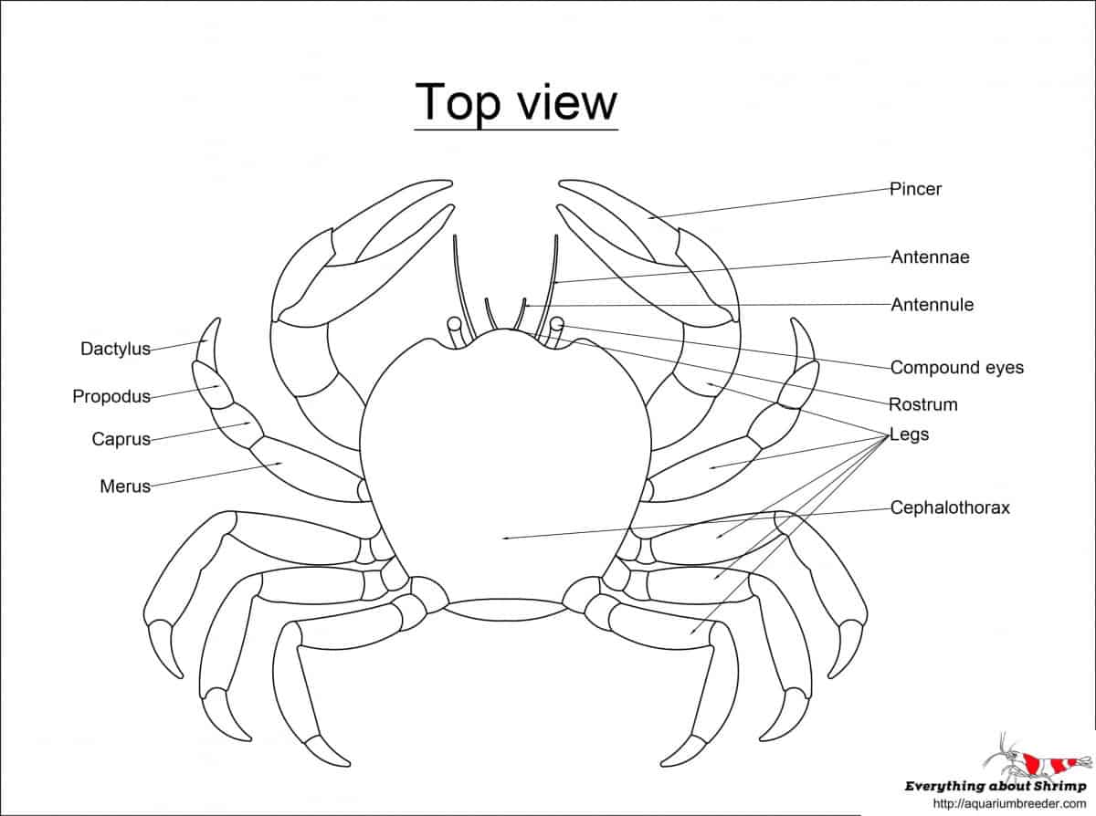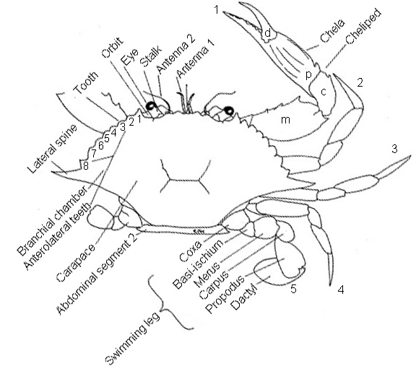

**Agonistic** : Behaviours which cause, threaten to cause, or seek to reduce physical damage (i.e. threats, aggression and submission).

**Carpus** :

**Cheliped** : one of the pair of legs that bears the large [chelae](https://www.merriam-webster.com/dictionary/chelae) in decapod crustaceans.

**Dactylus** : the part consisting of one or more joints of the tarsus of certain insects following the enlarged and modified first joint.

**Merus :**the meropodite of a chela constituting the enlarged palm of the hand.

**Pereiopod** : a leg joined to the [pereion](https://www.collinsdictionary.com/dictionary/english/pereion) of a [crustacean](https://www.collinsdictionary.com/dictionary/english/crustacean).

**Propodus** : The propodite of a crustacean limb, especially in a claw-bearing limb, where it forms the base of the claw and the fixed side of the pincer against which the mobile part (dactylus) closes.